**LAB EXPERIMENT – 7**

**Network Scanning Tool - NMAP**

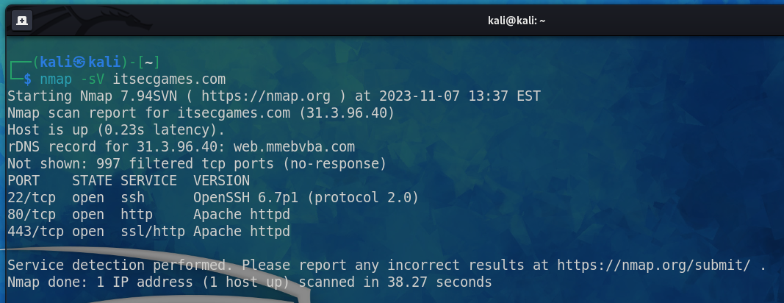

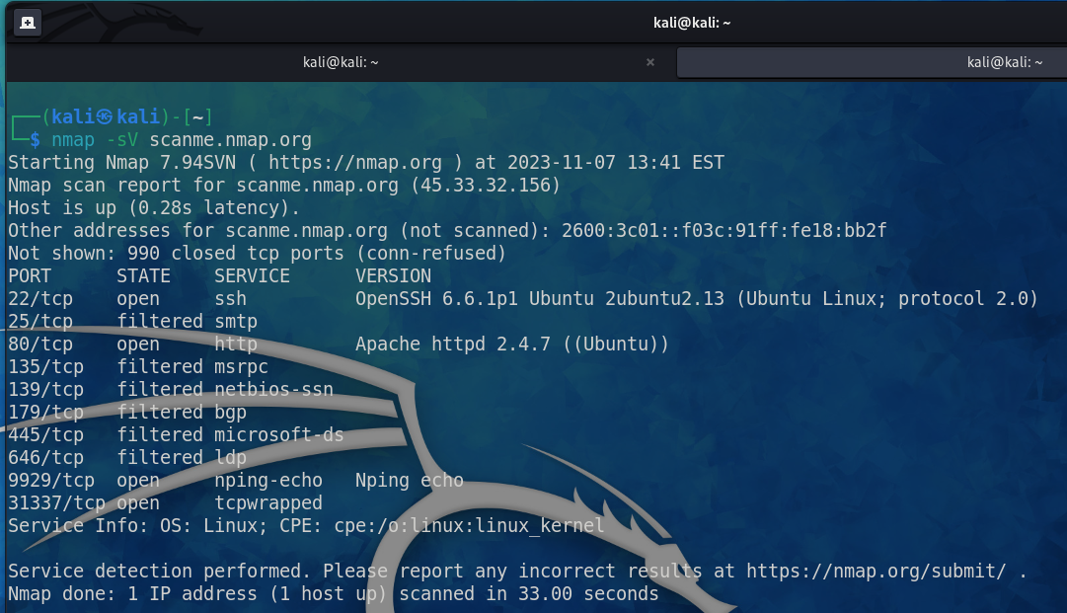

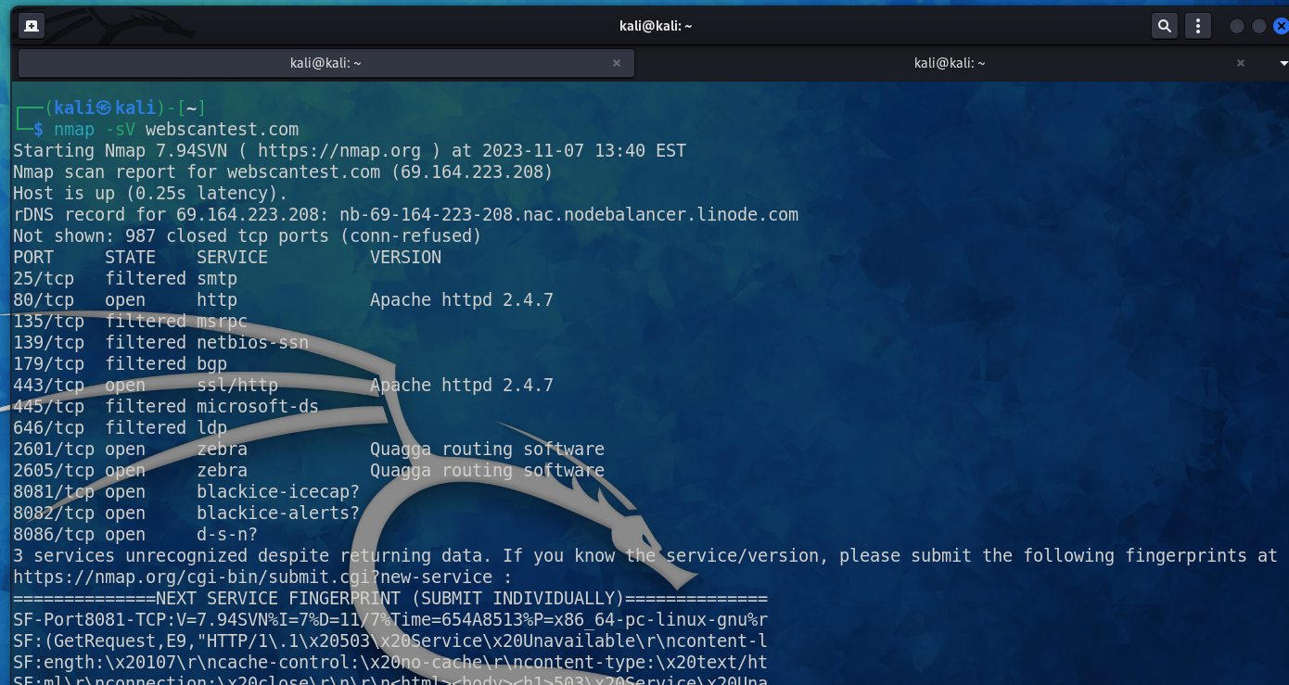

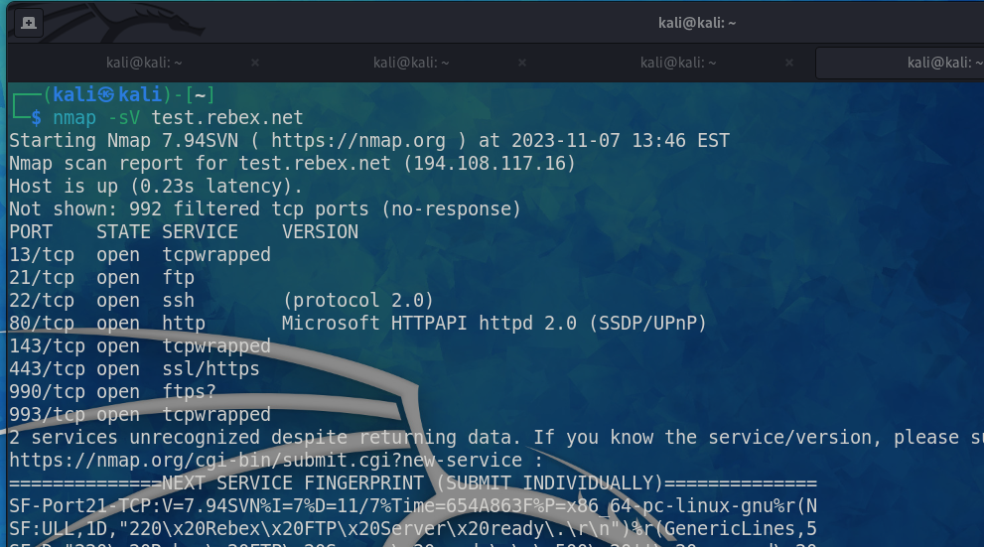

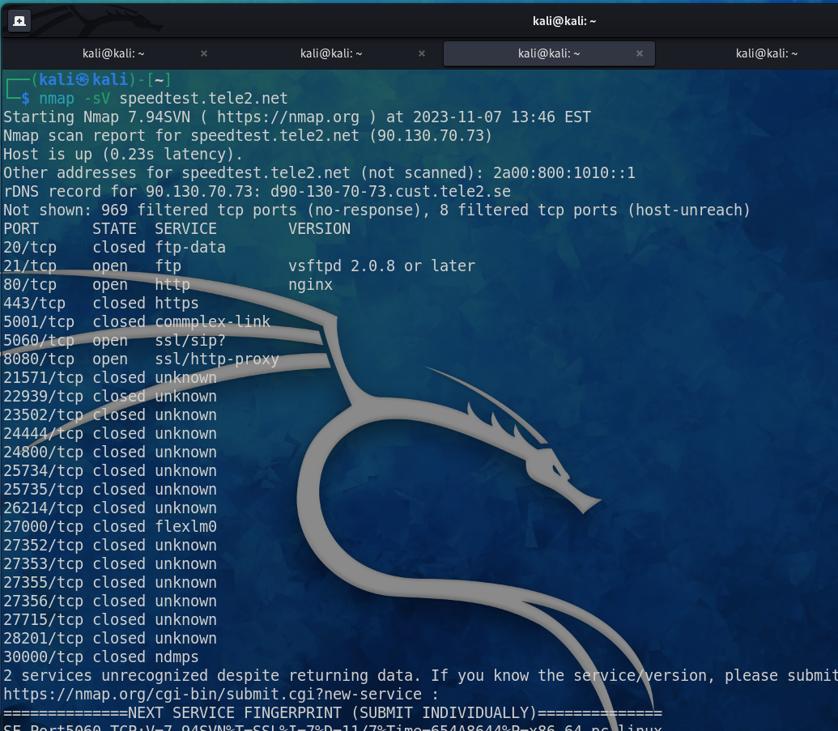

**Traceroute port 80 using nmap**

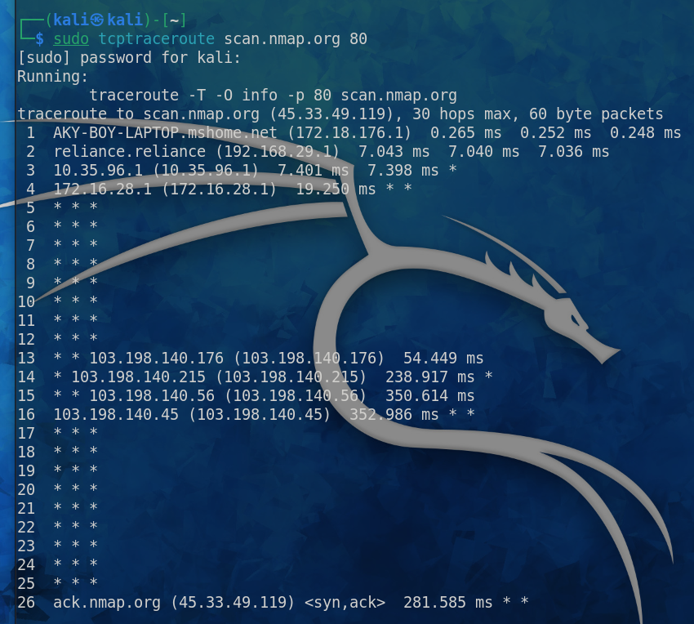

**To run the scans faster if you have faster internet use -T4 and for normal scan you can use -T3 or it’s the default way.**

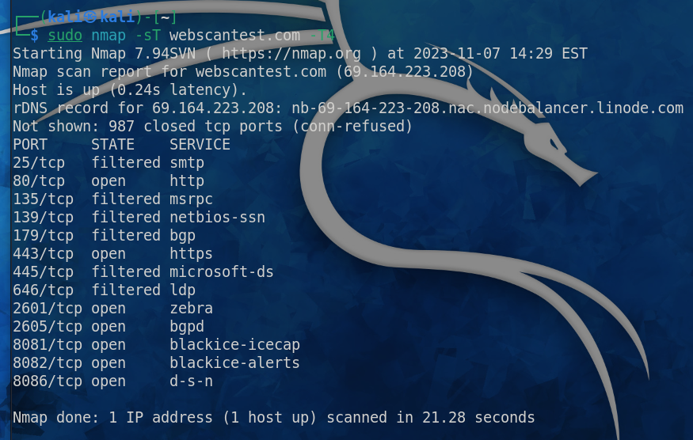

**To show the top ports from ranges 20.**

**And to show all the 65535 ports use -p-**

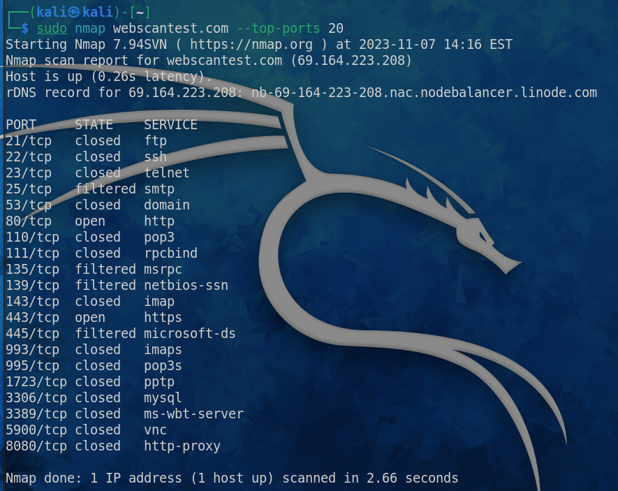

**Specific Protocol Type filtered SCAN**

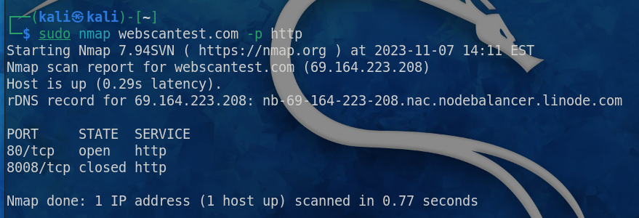

**Specific Port Type filtered SCAN**

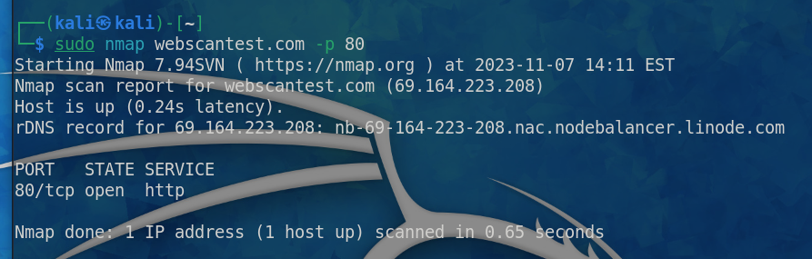

**For OS Detection on particular domain, we use -O**

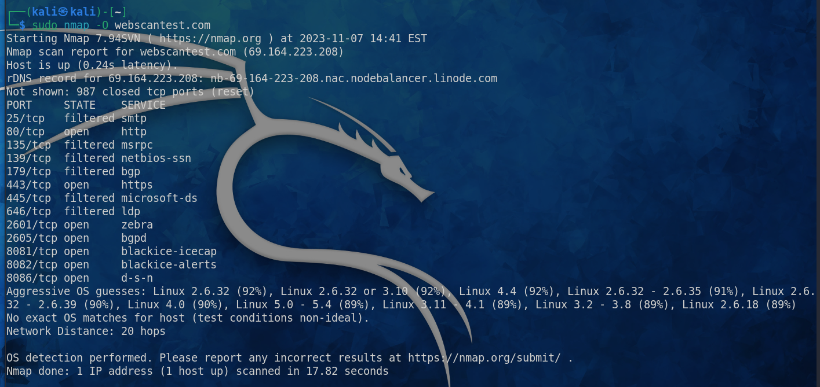

**WARNING**

This command is basically the mixture of all the commands and functionality of the nmap that is the -A which tells you about the Service Version + OS Detection + Scanning Ports + TraceRoute

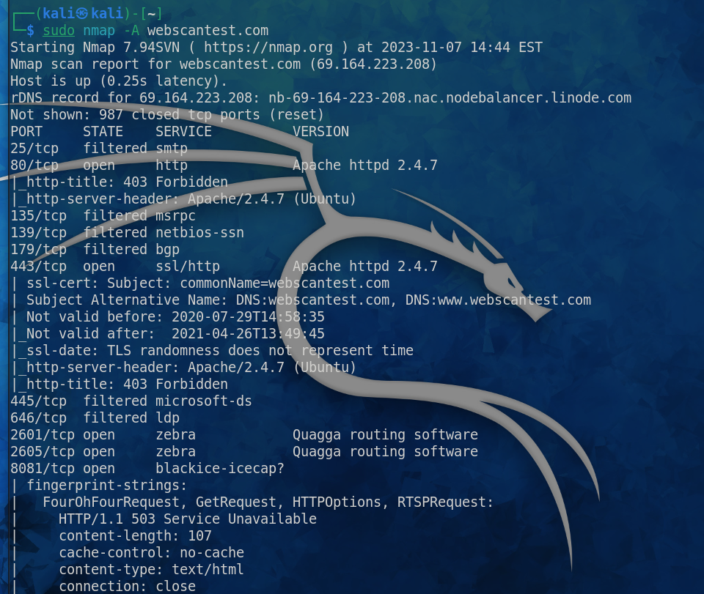

**This command shows you the live data, just like verbosity that is -v**

